- Consignee details
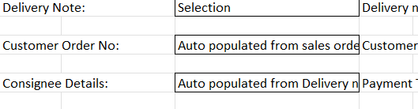
There can be multiple delivery Notes and all of them will have different Consignee Details. So iys impossible to control the number of Consignee Details field.
- Salesman List
Please provide the list for all salesman to create the lookup to let you select the desired salesman.
- Sales A/C

Please provide the tax to be charged on each of the Sales A/C in the dropdown

- Non Inventory Items

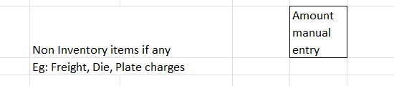
Single field as “Non-Inventory Amount” or different fields.
If different fields then provide the list of fields.

